Name: Parth Sandip Sante

Roll no. A055

Step 1: Search for EC2 and Click on it.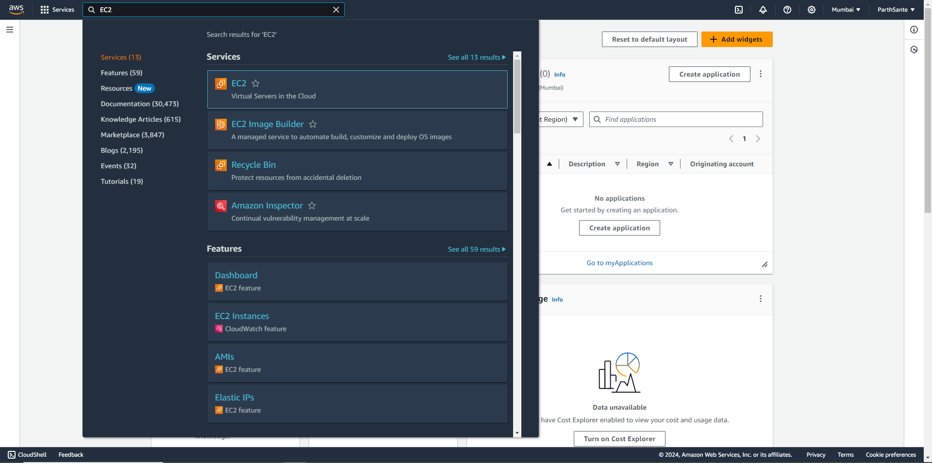

Step 2: Select the Launch Instance In the EC2 dashboard.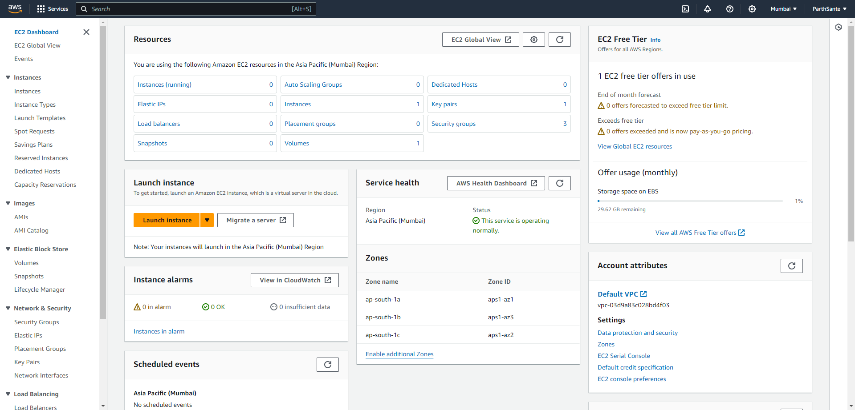

Step 3: Named instance as “CC_Practical_1” and Select Ubuntu under Quick start.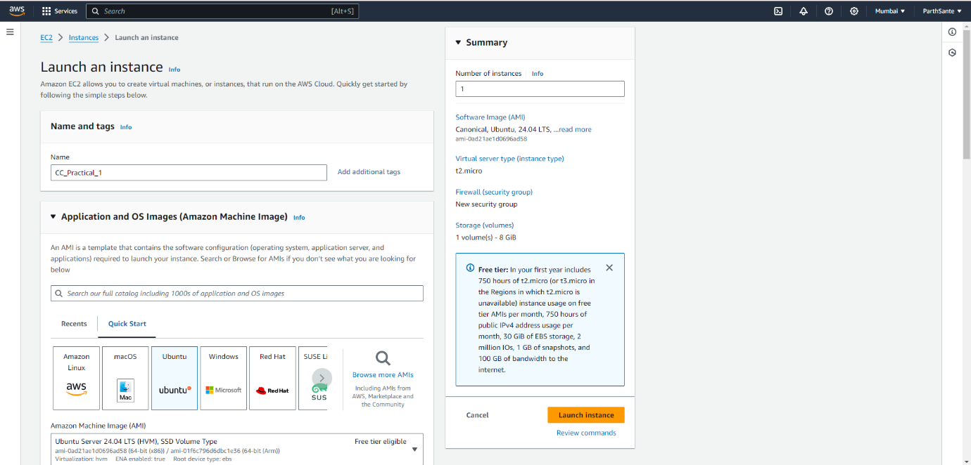

Step 4: Give the new pair key as “prac_1” and click on Create new pair key.

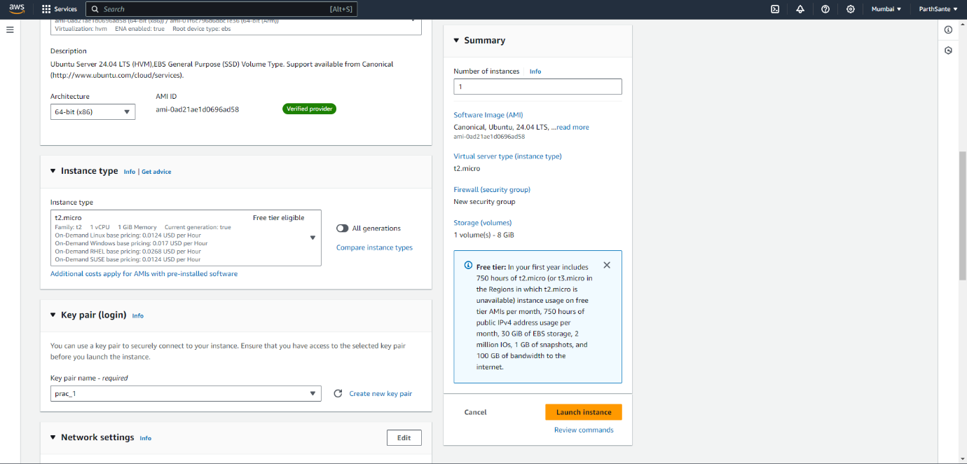

Step 5: Click on Launch Instance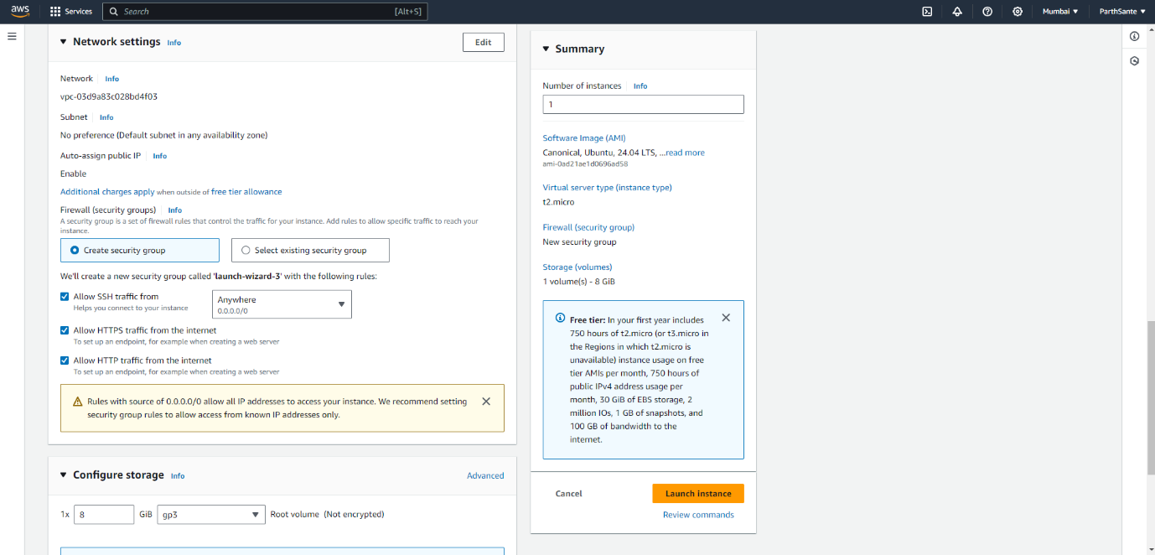

Step 6: You can see, instance is created.

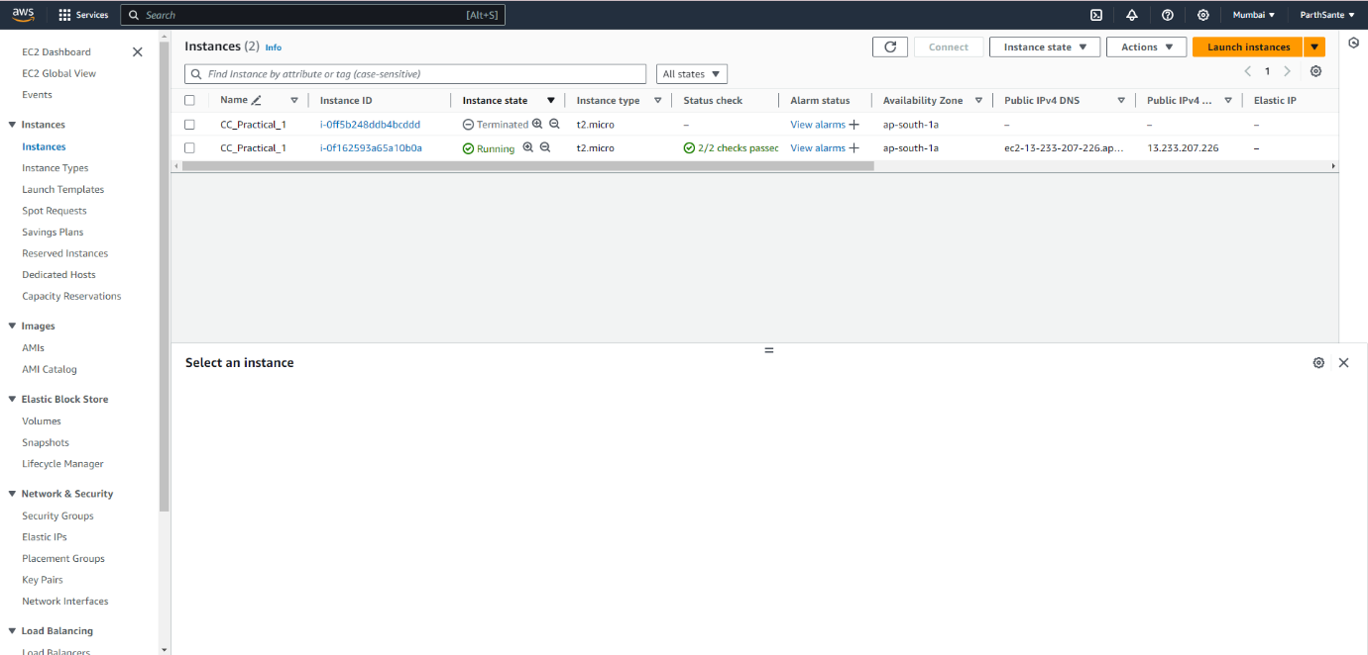

Step 7: Click on connect and the Instance is launched.

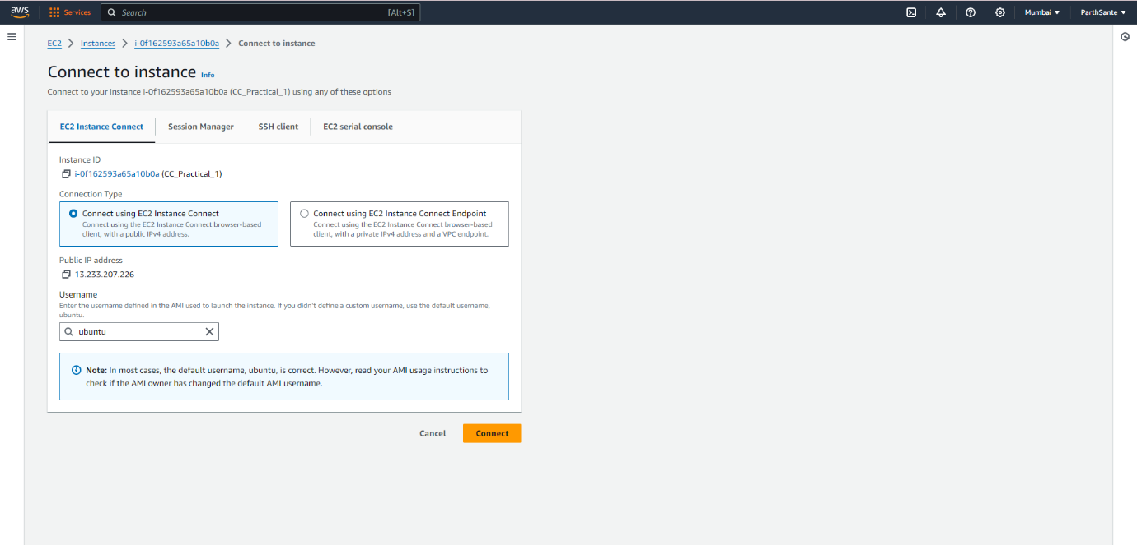

Step 8: Few commands are performed on Ubuntu platform.

